2. For a given set of training data examples stored in a .CSV file, implement and demonstrate the
Candidate-Elimination algorithm in python to output a description of the set of all hypotheses
consistent with the training examples
Procedure
- Define the training dataset.
- Initialize the Specific hypothesis (S).
- Initialize the General hypothesis (G).
- For positive examples, generalize S.
- For negative examples, specialize G.
- Update S and G after each iteration.
- Display the final hypotheses.
Dataset 1: Play Tennis
Sky | Temperature | Humidity | Wind | Water | Forecast | PlayTennis
Sunny | Warm | Normal | Strong | Warm | Same | Yes
Sunny | Warm | High | Strong | Warm | Same | Yes
Rainy | Cold | High | Strong | Warm | Change | No
Sunny | Warm | High | Strong | Cool | Same | Yes
Rainy | Warm | Normal | Weak | Warm | Same | No
Sunny | Warm | Normal | Weak | Warm | Same | Yes
Cloudy | Warm | Normal | Strong | Warm | Same | Yes
Sunny | Cold | High | Weak | Cool | Change | No
Target Attribute: PlayTennis

1. Candidate Elimination — Play Tennis
# Candidate Elimination Algorithm
# Dataset: Play Tennis
data = [
['Sunny', 'Warm', 'Normal', 'Strong', 'Warm', 'Same', 'Yes'],
['Sunny', 'Warm', 'High', 'Strong', 'Warm', 'Same', 'Yes'],
['Rainy', 'Cold', 'High', 'Strong', 'Warm', 'Change', 'No'],
['Sunny', 'Warm', 'High', 'Strong', 'Cool', 'Same', 'Yes'],
['Rainy', 'Warm', 'Normal', 'Weak', 'Warm', 'Same', 'No'],
['Sunny', 'Warm', 'Normal', 'Weak', 'Warm', 'Same', 'Yes'],
['Cloudy', 'Warm', 'Normal', 'Strong', 'Warm', 'Same', 'Yes'],
['Sunny', 'Cold', 'High', 'Weak', 'Cool', 'Change', 'No']
]
positive = "Yes"
n = len(data[0]) - 1
S = {tuple(['Ø'] * n)}
G = {tuple(['?'] * n)}
def covers(h, x):
return all(a == '?' or a == b for a, b in zip(h, x))
def more_general(g, s):
return all(a == '?' or a == b for a, b in zip(g, s))
domains = [
set(row[i] for row in data)
for i in range(n)
]
for row in data:
x = tuple(row[:-1])
label = row[-
if label == positive:
# Remove G hypotheses that do not cover positive example
G = {g for g in G if covers(g, x)}
new_S = set()
for s in S:
if covers(s, x):
new_S.add(s)
else:
h = list(s)
for i in range(n):
if h[i] == 'Ø':
h[i] = x[i]
elif h[i] != x[i]:
h[i] = '?'
new_S.add(tuple(h))
S = {
s for s in new_S
if any(more_general(g, s) for g in G)
}
else:
# Remove S hypotheses covering negative example
S = {s for s in S if not covers(s, x)}
new_G = set()
for g in G:
if not covers(g, x):
new_G.add(g)
else:
for i in range(n):
if g[i] == '?':
for value in domains[i]:
if value != x[i]:
h = list(g)
h[i] = value
h = tuple(h)
if any(more_general(h, s) for s in S):
new_G.add(h)
G = {
g for g in new_G
if any(more_general(g, s) for s in S)
}
print("Final Specific Boundary S:")
for s in S:
print(s)
print("\nFinal General Boundary G:")
for g in G:
print(g)
if not S or not G:
print("\nVersion Space is EMPTY")
print("No hypothesis is consistent with all training examples.")
output:
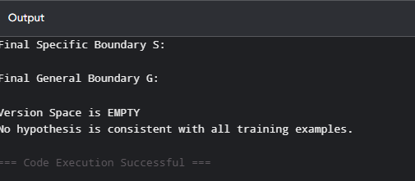

Dataset 2: Loan Approval
Income | Credit Score | Employment | Property | Age | Loan Approved
High | Good | Permanent | Yes | Young | Yes
High | Good | Permanent | No | Middle | Yes
Low | Poor | Temporary | No | Young | No
Medium | Good | Permanent | Yes | Middle | Yes
High | Average | Temporary | Yes | Old | No
Medium | Good | Permanent | No | Young | Yes
Low | Good | Permanent | Yes | Middle | Yes
Low | Poor | Temporary | Yes | Old | No
Target Attribute: Loan Approved
# Candidate Elimination Algorithm
# Dataset: Loan Approval

data = [
['High', 'Good', 'Permanent', 'Yes', 'Young', 'Yes'],
['High', 'Good', 'Permanent', 'No', 'Middle', 'Yes'],
['Low', 'Poor', 'Temporary', 'No', 'Young', 'No'],
['Medium', 'Good', 'Permanent', 'Yes', 'Middle', 'Yes'],
['High', 'Average', 'Temporary', 'Yes', 'Old', 'No'],
['Medium', 'Good', 'Permanent', 'No', 'Young', 'Yes'],
['Low', 'Good', 'Permanent', 'Yes', 'Middle', 'Yes'],
['Low', 'Poor', 'Temporary', 'Yes', 'Old', 'No']
]
positive = "Yes"
n = len(data[0]) - 1
S = {tuple(['Ø'] * n)}
G = {tuple(['?'] * n)}
def covers(h, x):
return all(a == '?' or a == b for a, b in zip(h, x))
def more_general(g, s):
return all(a == '?' or a == b for a, b in zip(g, s))
domains = [
set(row[i] for row in data)
for i in range(n)
]
for row in data:
x = tuple(row[:-1])
label = row[-1]
if label == positive:
G = {g for g in G if covers(g, x)}
new_S = set()
for s in S:
if covers(s, x):
new_S.add(s)
else:
h = list(s)
for i in range(n):
if h[i] == 'Ø':
h[i] = x[i]
elif h[i] != x[i]:
h[i] = '?'
new_S.add(tuple(h))
S = {
s for s in new_S
if any(more_general(g, s) for g in G)
}
else:
S = {s for s in S if not covers(s, x)}
new_G = set()
for g in G:
if not covers(g, x):
new_G.add(g)
else:
for i in range(n):
if g[i] == '?':
for value in domains[i]:
if value != x[i]:
h = list(g)
h[i] = value
h = tuple(h)
if any(more_general(h, s) for s in S):
new_G.add(h)
G = {
g for g in new_G
if any(more_general(g, s) for s in S)
}
print("Final Specific Boundary S:")
for s in S:
print(s)
print("\nFinal General Boundary G:")
for g in G:
print(g)
Output:
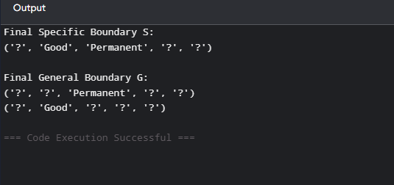

Dataset 3: Student Placement
CGPA | Communication | Internship | Programming | Aptitude | Placed
High | Good | Yes | Good | High | Yes
High | Excellent | Yes | Good | High | Yes
Medium | Average | No | Average | Medium | No
High | Good | Yes | Excellent | High | Yes
Low | Poor | No | Average | Low | No
High | Good | Yes | Good | Medium | Yes

Coding:
# Candidate Elimination Algorithm
# Dataset: Student Placement

data = [
['High', 'Good', 'Yes', 'Good', 'High', 'Yes'],
['High', 'Excellent', 'Yes', 'Good', 'High', 'Yes'],
['Medium', 'Average', 'No', 'Average', 'Medium', 'No'],
['High', 'Good', 'Yes', 'Excellent', 'High', 'Yes'],
['Low', 'Poor', 'No', 'Average', 'Low', 'No'],
['Average', 'Low', 'No', 'High', 'Good', 'Yes'],
['Good', 'Medium', 'Yes', 'Good', 'High', 'Yes'],
['Low', 'Average', 'No', 'Poor', 'Medium', 'No']
]

positive = "Yes"

n = len(data[0]) - 1

S = {tuple(['Ø'] * n)}
G = {tuple(['?'] * n)}

def covers(h, x):
return all(a == '?' or a == b for a, b in zip(h, x))

def more_general(g, s):
return all(a == '?' or a == b for a, b in zip(g, s))

domains = [
set(row[i] for row in data)
for i in range(n)
]

for row in data:

x = tuple(row[:-1])
label = row[-1]

if label == positive:

G = {g for g in G if covers(g, x)}

new_S = set()

for s in S:

if covers(s, x):
new_S.add(s)

else:

h = list(s)

for i in range(n):

if h[i] == 'Ø':
h[i] = x[i]

elif h[i] != x[i]:
h[i] = '?'

new_S.add(tuple(h))

S = {
s for s in new_S
if any(more_general(g, s) for g in G)
}

else:

S = {s for s in S if not covers(s, x)}

new_G = set()

for g in G:

if not covers(g, x):

new_G.add(g)

else:

for i in range(n):

if g[i] == '?':

for value in domains[i]:

if value != x[i]:

h = list(g)
h[i] = value
h = tuple(h)

if any(more_general(h, s) for s in S):
new_G.add(h)

G = {
g for g in new_G
if any(more_general(g, s) for s in S)
}

print("Final Specific Boundary S:")
for s in S:
print(s)

print("\nFinal General Boundary G:")
for g in G:
print(g)

if not S or not G:
print("\nVersion Space is EMPTY")
print("No consistent hypothesis exists.")
Output:
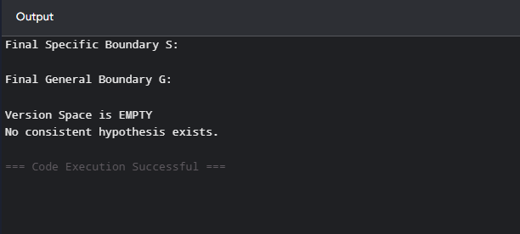

Dataset 4: Disease Diagnosis
Fever | Cough | Headache | Body Pain | Fatigue | Disease
Yes | Yes | Yes | Yes | Yes | Positive
Yes | Yes | No | Yes | Yes | Positive
No | Yes | Yes | No | No | Negative
Yes | Yes | Yes | No | Yes | Positive
No | No | Yes | Yes | No | Negative
Yes | Yes | No | No | Yes | Positive
Yes | No | Yes | Yes | Yes | Positive
No | No | No | No | No | Negative
Target Attribute: Disease
# Candidate Elimination Algorithm
# Dataset: Disease Diagnosis

data = [
['Yes', 'Yes', 'Yes', 'Yes', 'Yes', 'Positive'],
['Yes', 'Yes', 'No', 'Yes', 'Yes', 'Positive'],
['No', 'Yes', 'Yes', 'No', 'No', 'Negative'],
['Yes', 'Yes', 'Yes', 'No', 'Yes', 'Positive'],
['No', 'No', 'Yes', 'Yes', 'No', 'Negative'],
['Yes', 'Yes', 'No', 'No', 'Yes', 'Positive'],
['Yes', 'No', 'Yes', 'Yes', 'Yes', 'Positive'],
['No', 'No', 'No', 'No', 'No', 'Negative']
]

positive = "Positive"

n = len(data[0]) - 1

S = {tuple(['Ø'] * n)}
G = {tuple(['?'] * n)}

def covers(h, x):
return all(a == '?' or a == b for a, b in zip(h, x))

def more_general(g, s):
return all(a == '?' or a == b for a, b in zip(g, s))

domains = [
set(row[i] for row in data)
for i in range(n)
]

for row in data:

x = tuple(row[:-1])
label = row[-1]

if label == positive:

G = {g for g in G if covers(g, x)}

new_S = set()

for s in S:

if covers(s, x):
new_S.add(s)

else:

h = list(s)

for i in range(n):

if h[i] == 'Ø':
h[i] = x[i]

elif h[i] != x[i]:
h[i] = '?'

new_S.add(tuple(h))

S = {
s for s in new_S
if any(more_general(g, s) for g in G)
}

else:

S = {s for s in S if not covers(s, x)}

new_G = set()

for g in G:

if not covers(g, x):

new_G.add(g)

else:

for i in range(n):

if g[i] == '?':

for value in domains[i]:

if value != x[i]:

h = list(g)
h[i] = value
h = tuple(h)

if any(more_general(h, s) for s in S):
new_G.add(h)
G = {
g for g in new_G
if any(more_general(g, s) for s in S)
}
print("Final Specific Boundary S:")
for s in S:
print(s)
print("\nFinal General Boundary G:")
for g in G:
print(g)

Output:
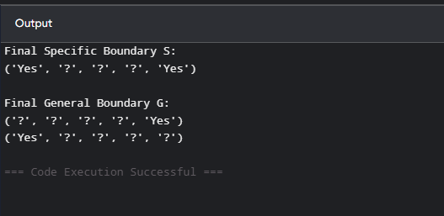

Dataset 5: Email Spam Detection
Contains Link | Contains Offer | Unknown Sender | Attachment | Many Recipients | Spam
Yes | Yes | Yes | No | Yes | Yes
Yes | Yes | Yes | Yes | Yes | Yes
No | No | No | No | No | No
Yes | No | Yes | No | Yes | Yes
No | Yes | No | Yes | No | No
Yes | Yes | Yes | No | No | Yes
Yes | No | Yes | Yes | Yes | Yes
No | No | Yes | No | No | No
Target Attribute: Spam
# Candidate Elimination Algorithm
# Dataset: Email Spam Detection

data = [
['Yes', 'Yes', 'Yes', 'No', 'Yes', 'Yes'],
['Yes', 'Yes', 'Yes', 'Yes', 'Yes', 'Yes'],
['No', 'No', 'No', 'No', 'No', 'No'],
['Yes', 'No', 'Yes', 'No', 'Yes', 'Yes'],
['No', 'Yes', 'No', 'Yes', 'No', 'No'],
['Yes', 'Yes', 'Yes', 'No', 'No', 'Yes'],
['Yes', 'No', 'Yes', 'No', 'No', 'Yes'],
['Yes', 'Yes', 'Yes', 'Yes', 'No', 'Yes'],
['Yes', 'Yes', 'Yes', 'Yes', 'Yes', 'Yes'],
['No', 'No', 'No', 'No', 'No', 'No']
]

positive = "Yes"

n = len(data[0]) - 1

S = {tuple(['Ø'] * n)}
G = {tuple(['?'] * n)}

def covers(h, x):
return all(a == '?' or a == b for a, b in zip(h, x))

def more_general(g, s):
return all(a == '?' or a == b for a, b in zip(g, s))

domains = [
set(row[i] for row in data)
for i in range(n)
]

for row in data:

x = tuple(row[:-1])
label = row[-1]

if label == positive:

G = {g for g in G if covers(g, x)}

new_S = set()

for s in S:

if covers(s, x):
new_S.add(s)

else:

h = list(s)

for i in range(n):

if h[i] == 'Ø':
h[i] = x[i]

elif h[i] != x[i]:
h[i] = '?'

new_S.add(tuple(h))

S = {
s for s in new_S
if any(more_general(g, s) for g in G)
}

else:

S = {s for s in S if not covers(s, x)}

new_G = set()

for g in G:

if not covers(g, x):

new_G.add(g)

else:

for i in range(n):

if g[i] == '?':
for value in domains[i]:

if value != x[i]:

h = list(g)
h[i] = value
h = tuple(h)

if any(more_general(h, s) for s in S):
new_G.add(h)

G = {
g for g in new_G
if any(more_general(g, s) for s in S)
}

print("Final Specific Boundary S:")
for s in S:
print(s)

print("\nFinal General Boundary G:")
for g in G:
print(g)
Output:
